A. Down Sampling
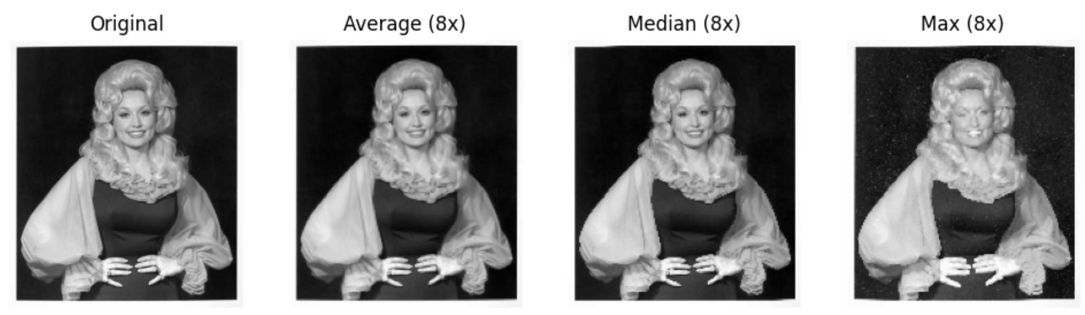
- Average
kernel = np.ones((8, 8)) / 64
return ndimage.convolve(image, kernel)[::8, ::8]

It divides the image into 64x64 grid, then box them into 8x8 grid, then within each 8x8 grid, calculate the average of the 8 pixels in it. Then replace the 8 pixels with just 1 value that is the average. It will then turn the image that’s originally 64x64 to 8x8. This makes the resolution less but the image still looks recognizable.

- Median
return ndimage.median_filter(image, size=8)[::8, ::8]

It divides the image into 64x64 grid, then box them into 8x8 grid, then within each 8x8 grid, calculate the mean of the 8 pixels in it. Then replace the 8 pixels with just 1 value that is the mean. It will then turn the image that’s originally 64x64 to 8x8. Like the average, this makes the resolution less but the image still looks recognizable. Although I think it’s a little less like the original, since we’re taking the mean, which isn’t necessarily a perfect representation of the entire 8x8 pixels we’re shrinking.
- Max
return ndimage.maximum_filter(image, size=8)[::8, ::8]

It divides the image into 64x64 grid, then box them into 8x8 grid, then within each 8x8 grid, calculate the max value of the 8 pixels in it. Then replace the 8 pixels with just 1 value that is the max one. It will then turn the image that’s originally 64x64 to 8x8. Unlike the average and mean one, this makes the image a lot less recognizable, and overall brighter since we’re only taking the maximum value from each 8x8 grid. As we can see here, dolly’s face turns into a strange bright mix that’s hardly recognizable anymore. The eye part especially becomes totally different too.

A. Up Sampling
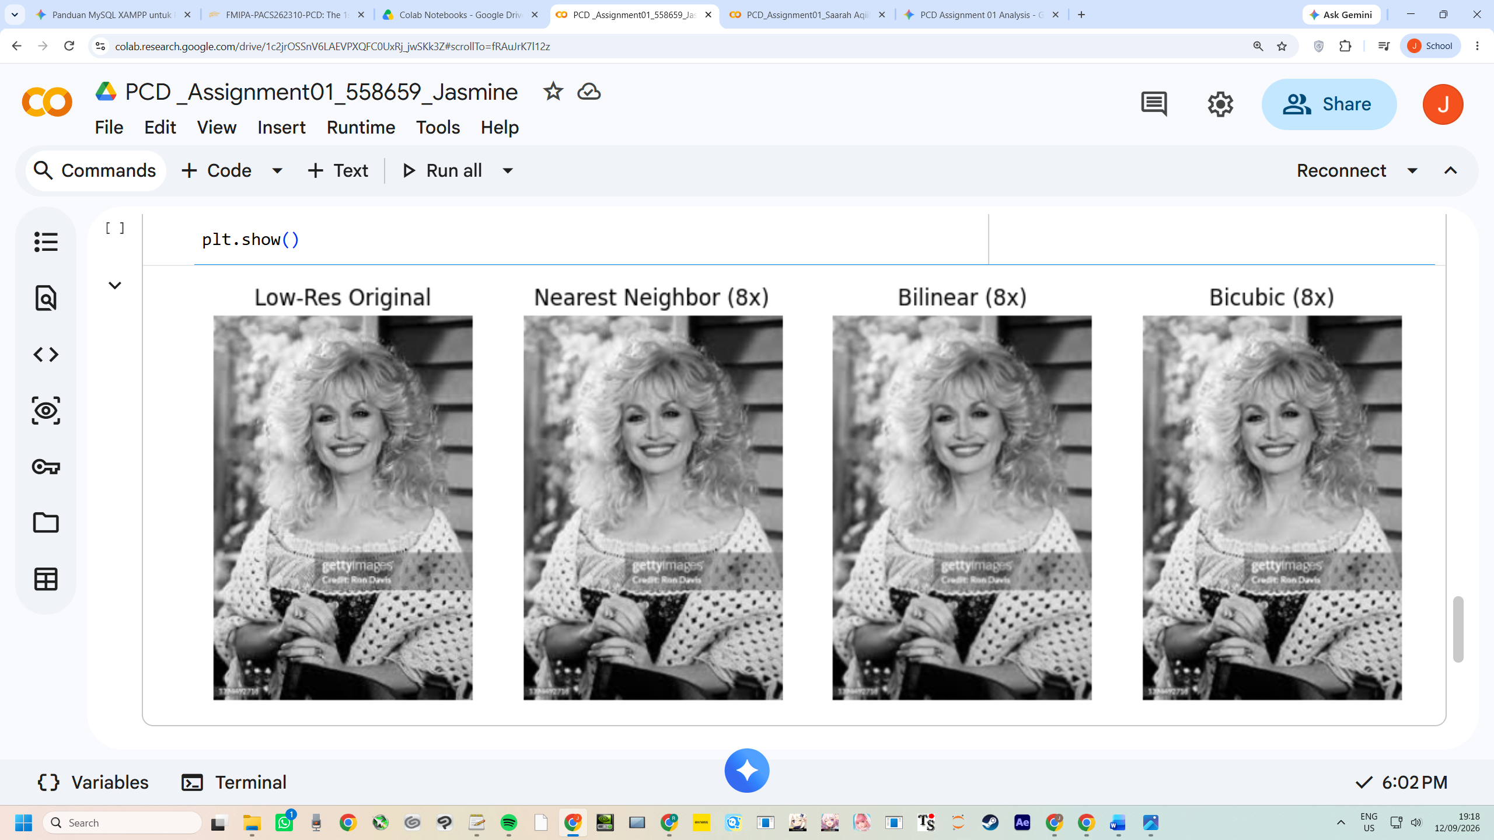
For the up sampling, I used opencv’s pre compiled algorithms that I added on the top like this import cv2 so I can access the nearest neighbor, bilinear, and bicubic up sampling algorithms easily.

- Nearest neighbor
def nn_upsampling(image):
h, w = image.shape
return cv2.resize(image, (w * 8, h * 8), interpolation=cv2.INTER_NEAREST)

In the nn_upsampling function, the code gets the image dimensions with h, w = image.shape and multiplies both by 8 to build a target grid size of (w * 8, h * 8). Passing interpolation=cv2.INTER_NEAREST into cv2.resize() triggers opencv’s nearest neighbor algorithm. When stretching an image 8x, opencv creates 63 empty pixel slots for every original pixel. This algorithm maps each new empty coordinate back to the original image grid, rounds to the nearest whole pixel position, and copies that exact intensity value over without doing any blending math. Because whole blocks of 64 new pixels end up copying the exact same original value, the upscaled image turns into giant, visible pixel squares with rough edges (although the result is a biiit invisible to see to the naked eye).

- Bilinear
def bilinear_upsampling(image):
h, w = image.shape
return cv2.resize(image, (w * 8, h * 8), interpolation=cv2.INTER_LINEAR)

The bilinear_upsampling function uses the same (w * 8, h * 8) target grid dimensions, but switches the algorithm flag to interpolation=cv2.INTER_LINEAR. When a new missing pixel lands between original pixels, opencv looks at its 4 closest neighbors (a 2x2 pixel grid). It performs linear interpolation twice: first it calculates distance-weighted averages horizontally along the top and bottom rows, and then it averages those results vertically. If a missing pixel is closer to the top-left neighbor, that top-left pixel gets a stronger weight in the final color calculation. This distance-weighted blending wipes out hard pixel boundaries to create smooth color transitions, but because it relies on basic straight-line averages, sharp contrast edges get smoothed out and end up looking a bit soft or fuzzy.
- Bicubic
def bicubic_upsampling(image):
h, w = image.shape
return cv2.resize(image, (w * 8, h * 8), interpolation=cv2.INTER_CUBIC)

In bicubic_upsampling, the code scales the array to (w * 8, h * 8) using interpolation=cv2.INTER_CUBIC. Instead of just looking at 4 pixels, Bicubic expands the search area to a 4x4 grid of 16 surrounding original pixels. It uses third-order polynomials (cubic spline curves) rather than straight lines to estimate missing pixel values. By evaluating 16 surrounding pixels at once, the algorithm tracks how pixel intensity values are changing (their slopes) across the neighborhood. This allows it to reconstruct smooth curves and sharp edge transitions much more accurately. At an 8x expansion, Bicubic produces the cleanest visual result it eliminates blocky pixelation while keeping edge details crisp, avoiding the extra blur that Bilinear does.

